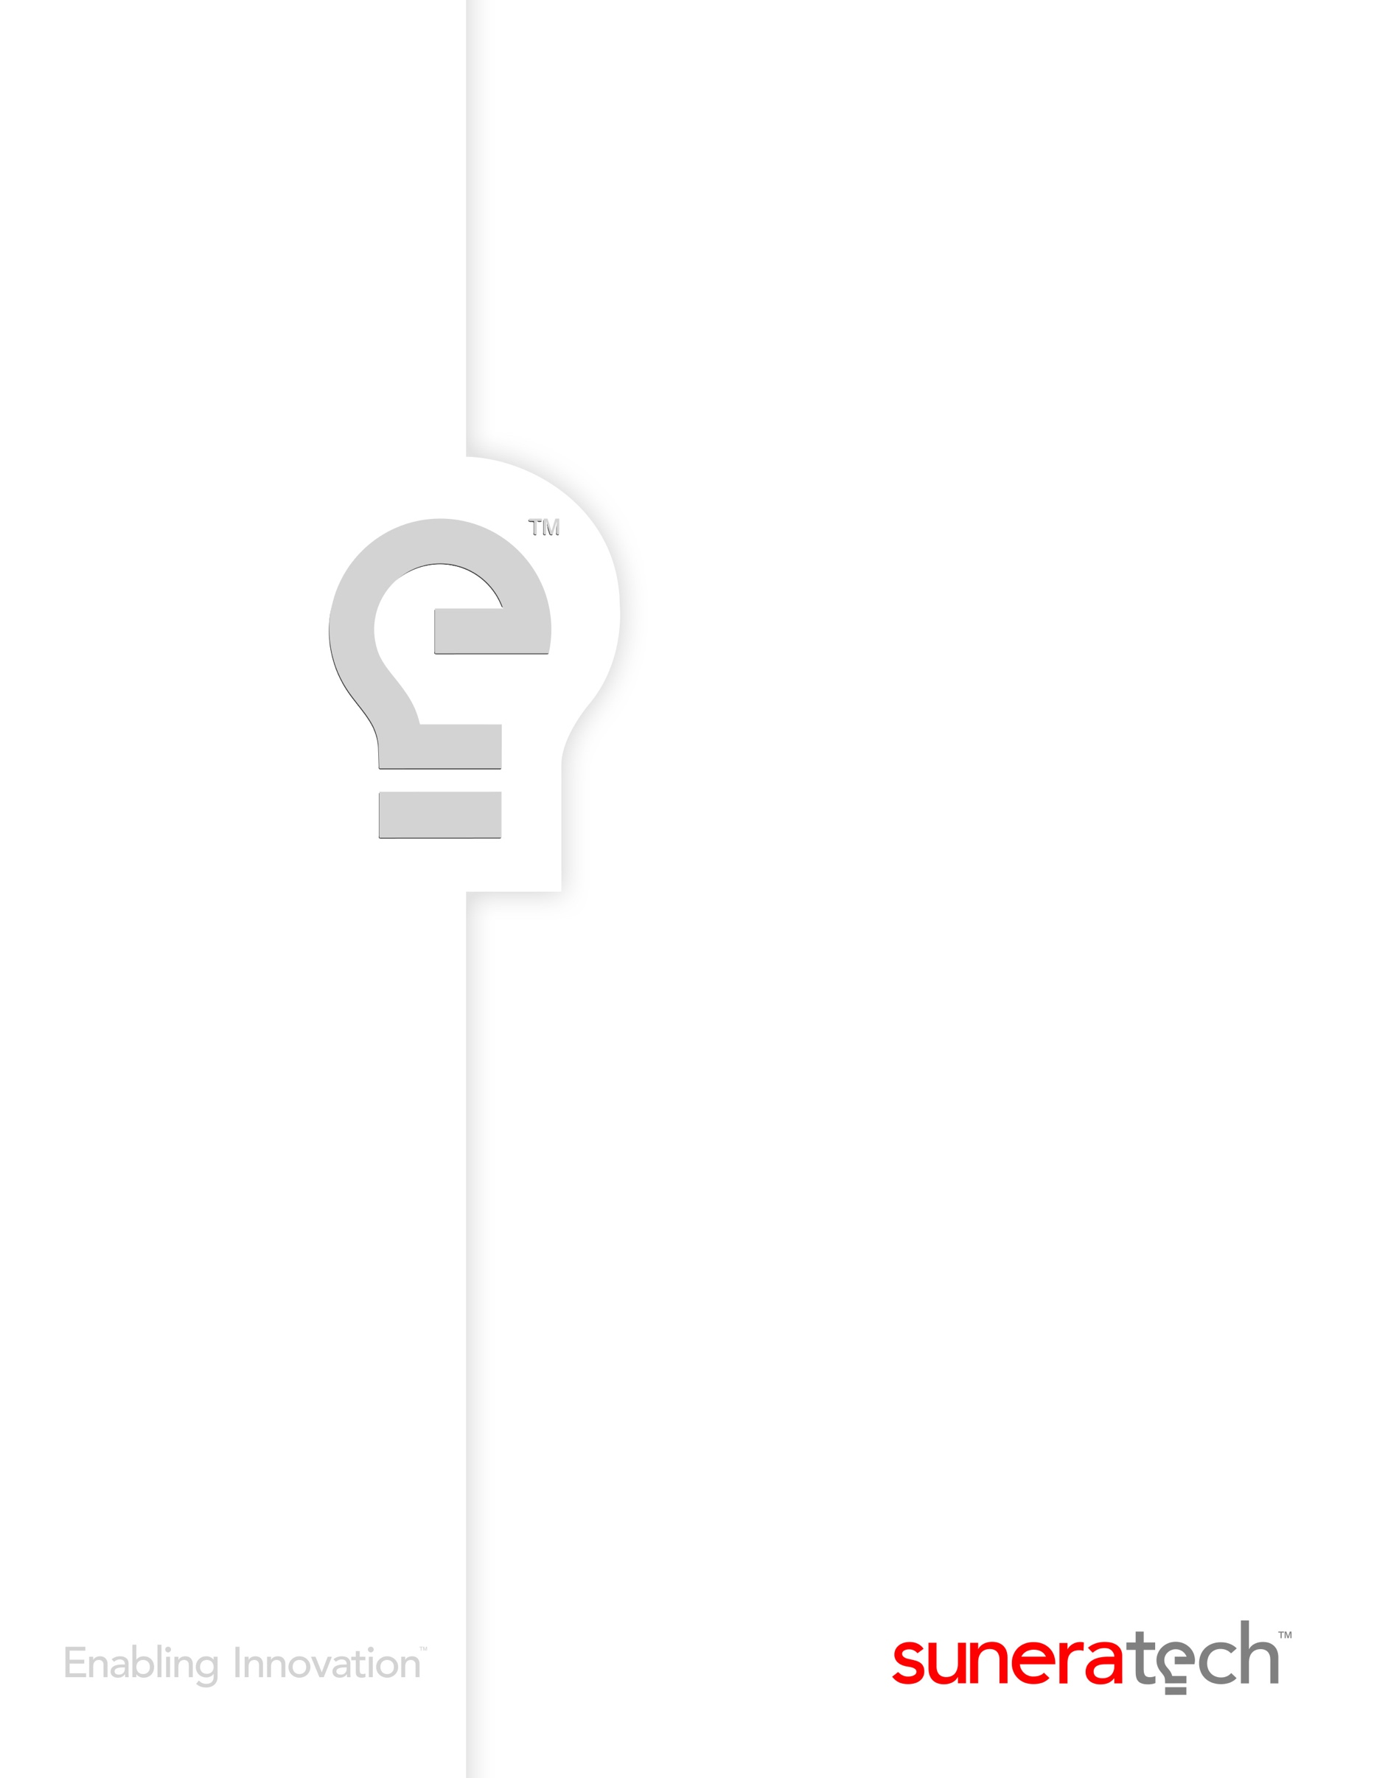

**Development Alternatives Inc.**

**Website Development Project - SBG**

**Portal Walkthrough document**

**01 Apr 2019**

Jan 07, 2017

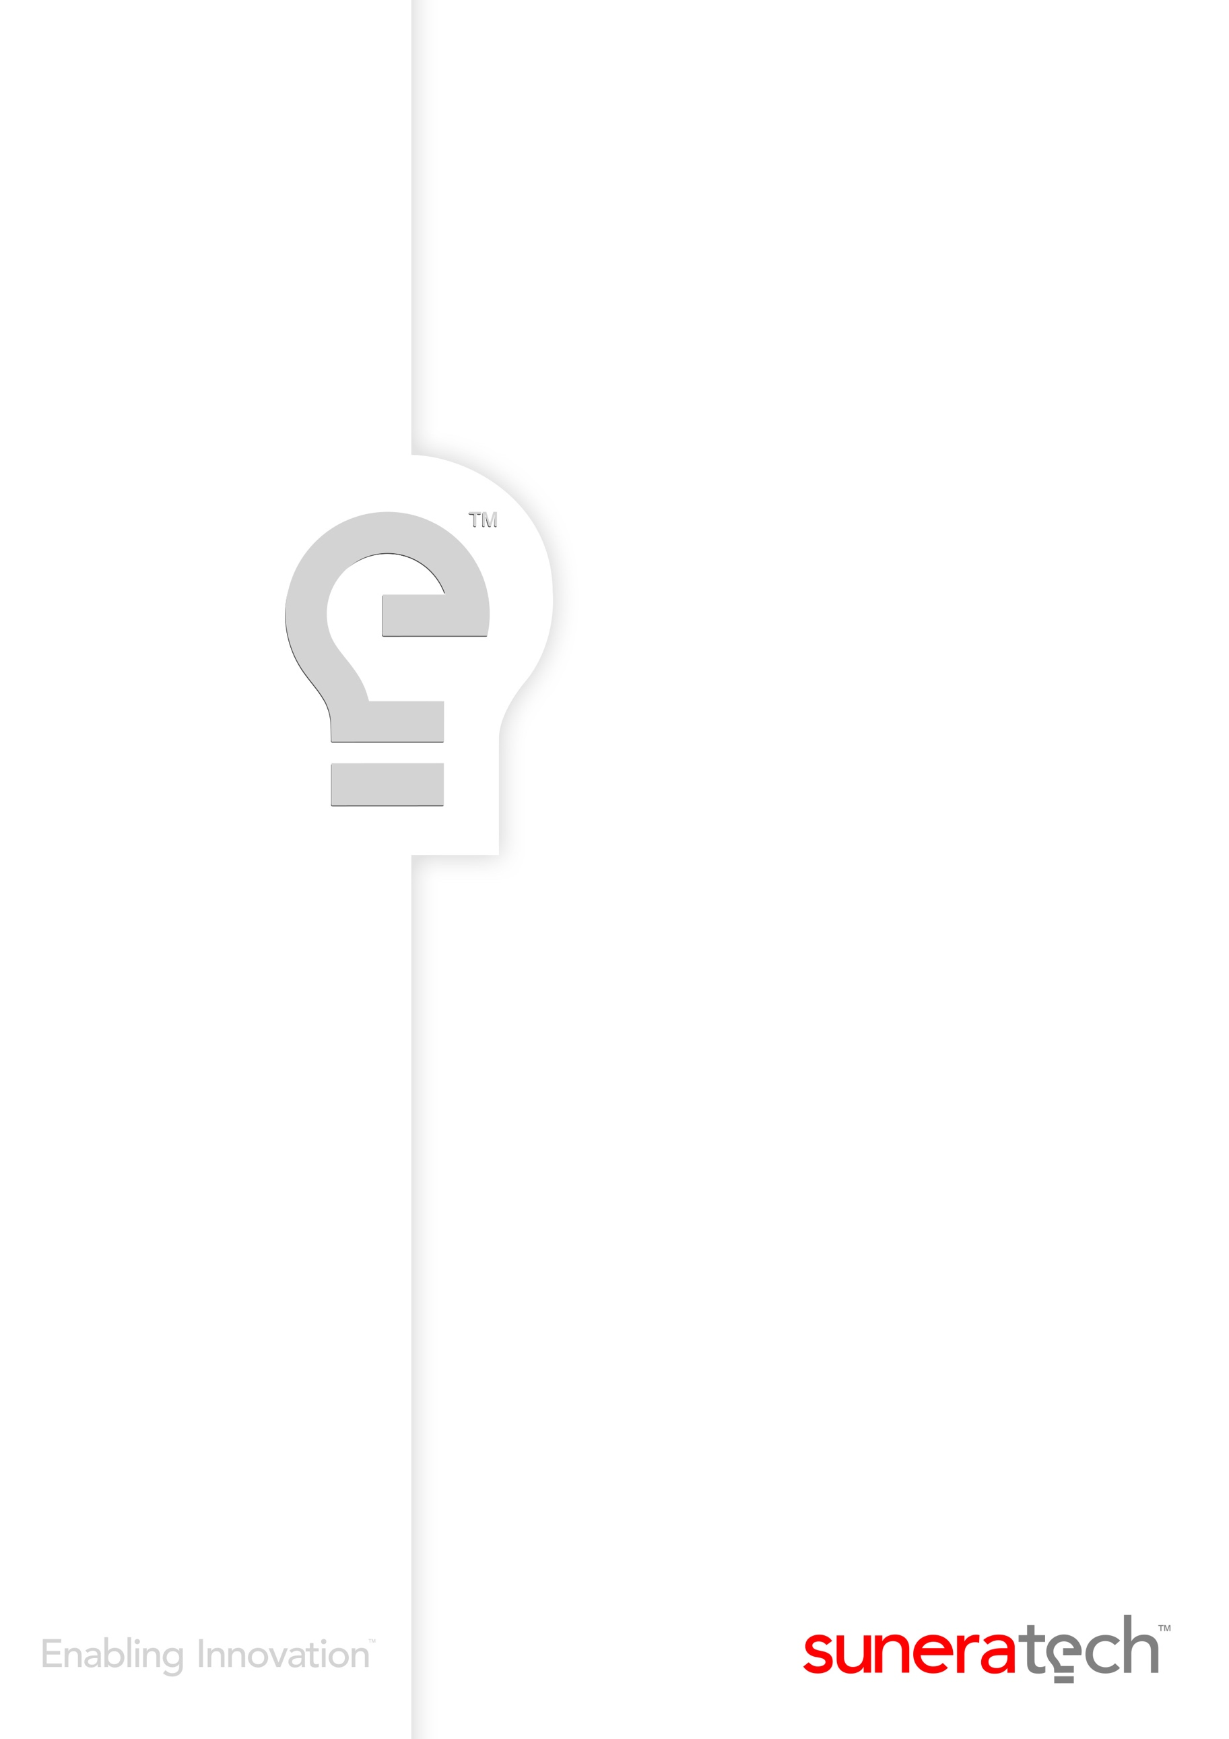

**Table of Contents**

1 General 3

2 URLs & Login details: 3

3 Dashboard Page 3

4 COMMUNITY OF PRACTICES: 4

5 COURSE DETAILS MODULE: 7

6 CMS Page: 11

7 UPCOMING MASTER CLASSES: 17

8 USERS MODULE: 20

9 COURSE MATERIAL MANAGEMENT: 24

# General

**Fonts used:** FranklinGothic-Book, Gotham-Book

**Banner Background Color:** Dark Gray/Blue

**Images:** Taken from PPT provided by DAI

**Buttons:** Orange, Earth Brown, Blue, Smoky Gray

# URLs & Login details:

**Front-end :**<http://129.213.78.114/public/index.php>

**Admin :**<http://129.213.78.114/public/index.php/admin>

**Username :** [kishore.neelam@suneratech.com](mailto:kishore.neelam@suneratech.com)

**Password :** iqadmin

# Dashboard Page

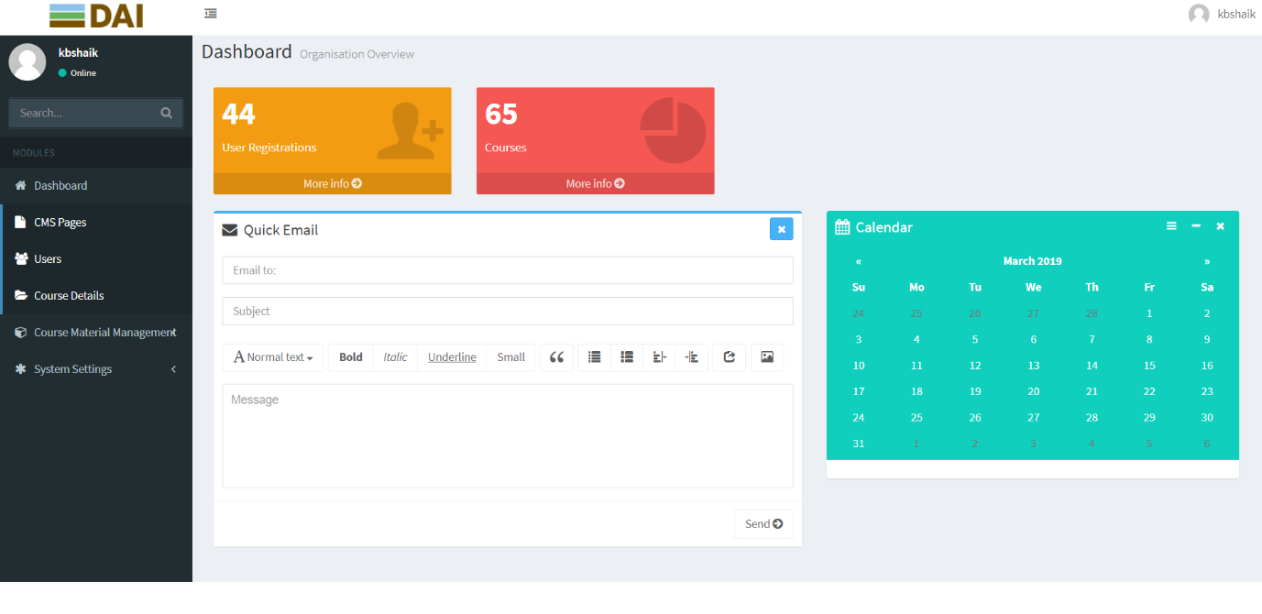

**About the Screen:**

This is the landing page after login. This dashboard page displays portal metrics, such as User Registrations, Number of Courses etc.

# COMMUNITY OF PRACTICES:

In community of practices module, the user can able to see LinkedIn, Twitter links and the fields provided are in this page are Id, Twitter, LinkedIn, Content, Banner, BannerHeader1, BannerHeader2, Actions.

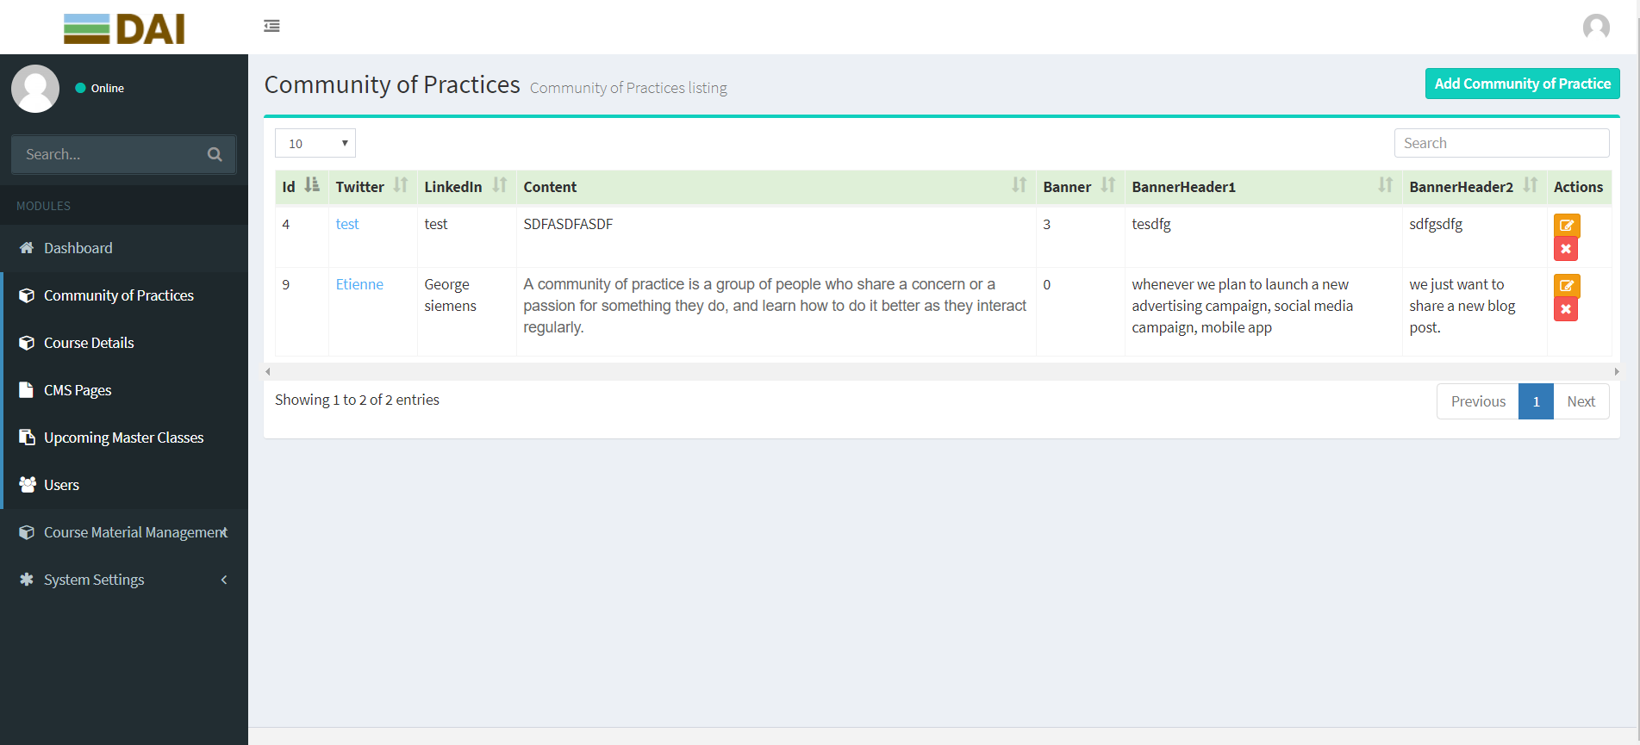

**About the field TWITTER:**

This is in the community of practices page. When we click on TEST, we will get all the information about test page.

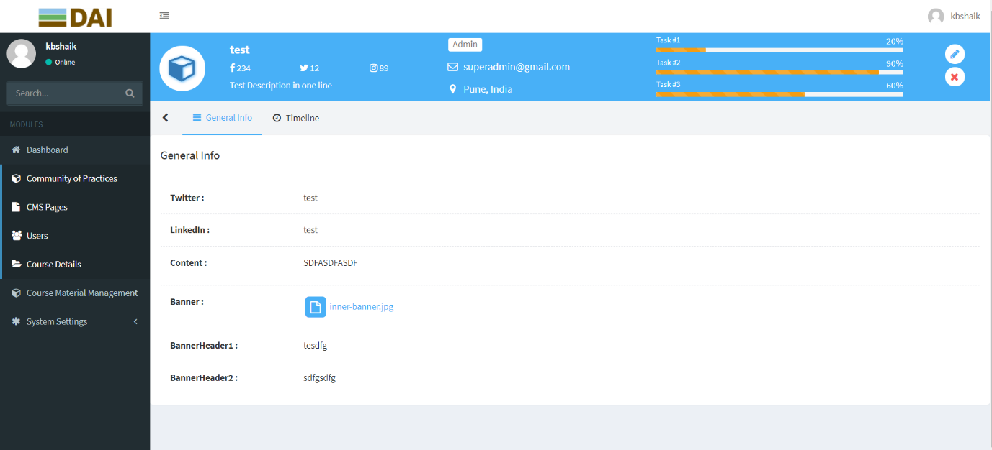

**COMMUNITY OF PRACTICES Page: ACTIONS-> EDIT ICON**

Here we have given the Add / Edit / Remove in actions field and when we click on edit option the below page will display so that we can edit the changes and we can update it.

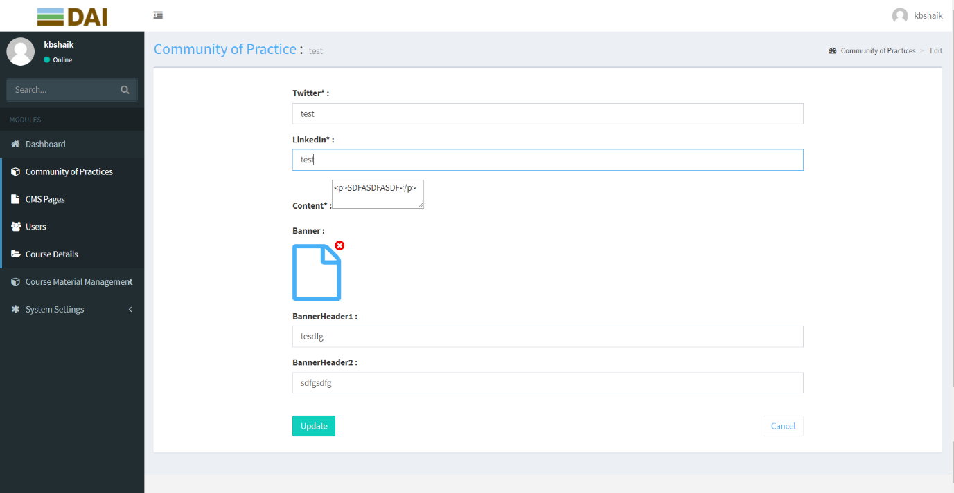

**About the Screen:**

Once we updated with all the pages and images then it will get updated with the new content and new images.

**COMMUNITY OF PRACTICES Page: ACTIONS-> REMOVE ICON**

Page can be deleted using this option. Click on ‘X’ mark under ‘Actions’ column. Using this option deleted the page permanently.



**COMMUNITY OF PRACTICES Page: ADD COMMUNITY OF PRACTICES Module**

If you want to create a new COMMUNITY OF PRACTICES page on the top right-side corner, you can find a button with the name “ADD COMMUNITY OF PRACTICES”.

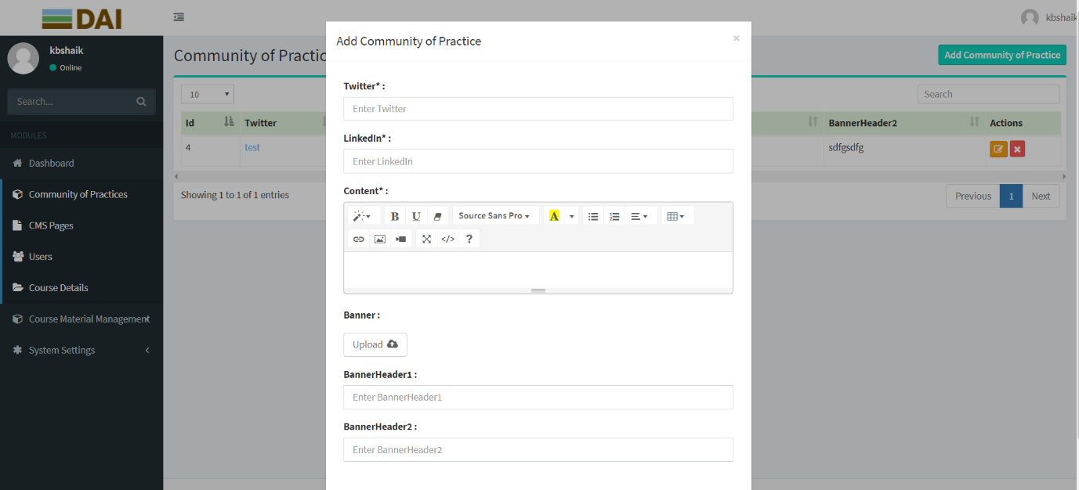

**About the Screen:**

Once we click on the add COMMUNITY OF PRACTICES page button you will find the pop-up with related fields to create the new COMMUNITY OF PRACTICES page.

# COURSE DETAILS MODULE:

In course details page we will manage the content of the page and the fields provided in this page are Id, Course Name, Course Description, Application Form, Start Date, End Date, Status, Actions.

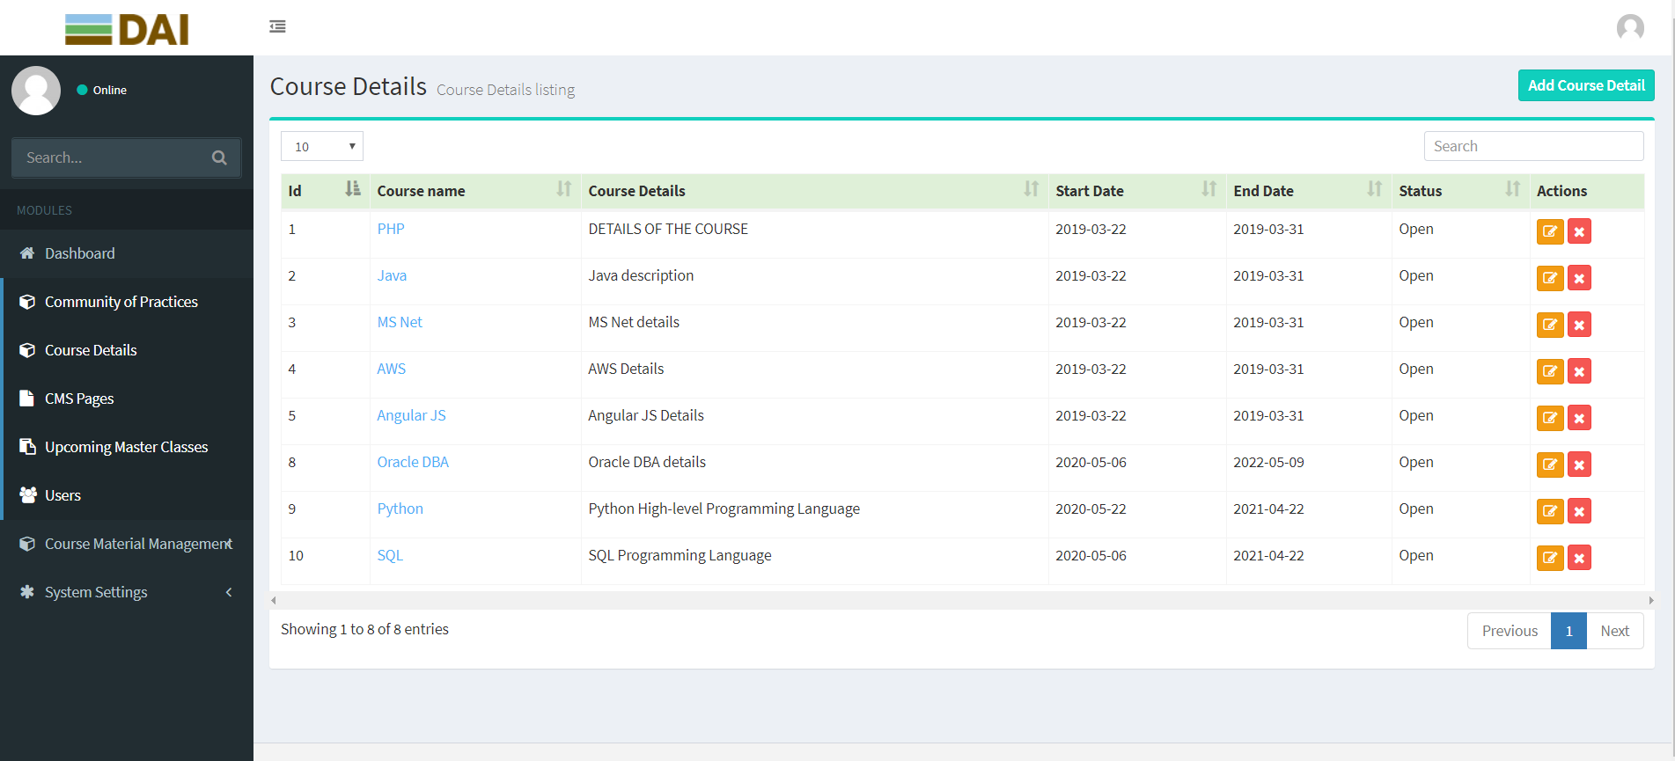

**About the field COURSE NAME:**

This is the COURSE DETAILS page. Here when we click on Course Name then we will get all the information about course name page.

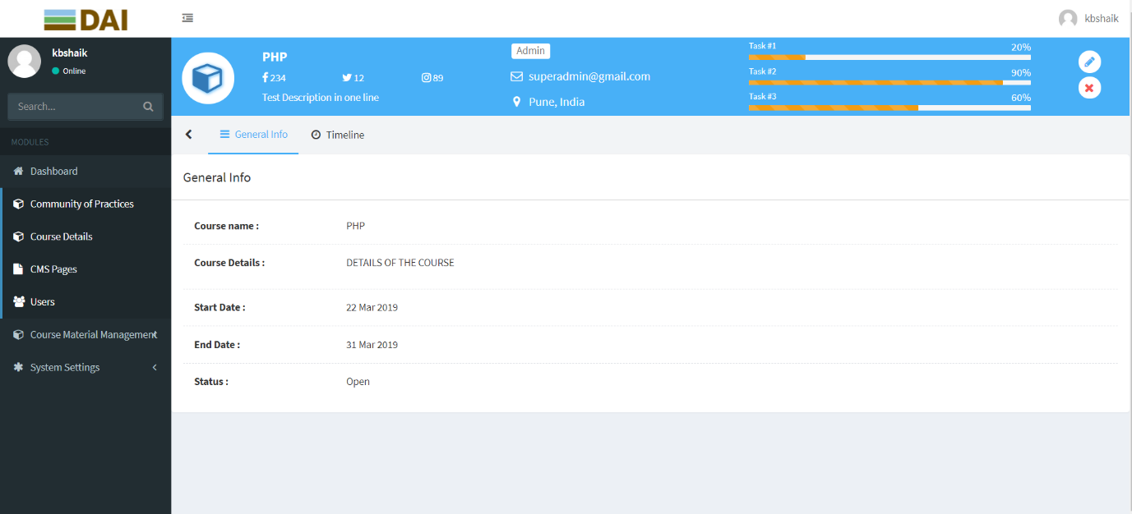

**COURSE DETAILS Page: ACTIONS-> EDIT ICON**

Here we have given the Add / Edit / Remove in actions field and when we click on edit option the below page will display so that we can edit the changes and we can update it.

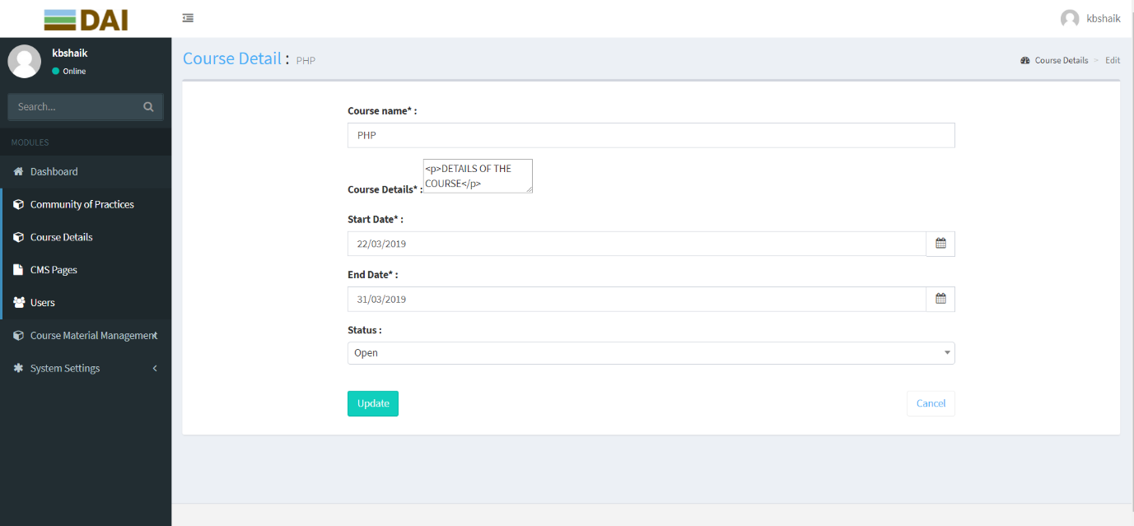

**COURSE DETAILS Page: ACTIONS-> REMOVE ICON**

If you want to delete a particular page in Actions column you can find a close icon. If we click on the close icon the particular page will be deleted and can’t be seen.



**About the Screen:**

Once we updated with all the pages and images then it will get updated with the new content and new images.

**COURSE DETAILS Page: ADD COURSE DETAIL Module**

If you want to create a new COURSE DETAIL page on the top right-side corner, you can find a button with the name “ADD COURSE DETAIL”.

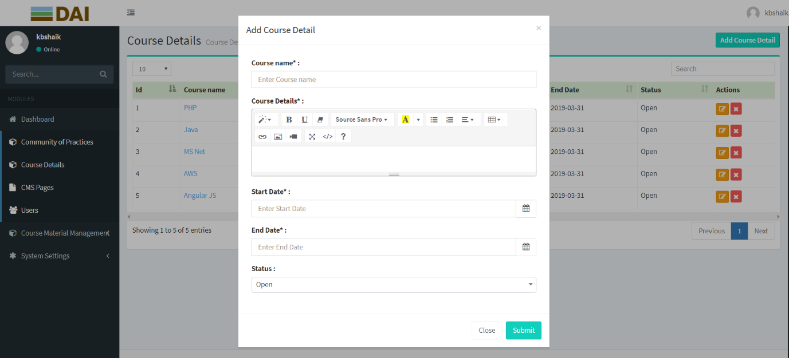

**About the Screen:**

Once we click on the add CMS page button you will find the pop-up with related fields to create the new COURSE DETAIL page.

# CMS Page:

In CMS pages we can add/edit website pages content and images like Heading Page Title, Page sub-title, Background 1, Background 2, Banner text, Content Block-1, Content Block-2, Status, Actions.

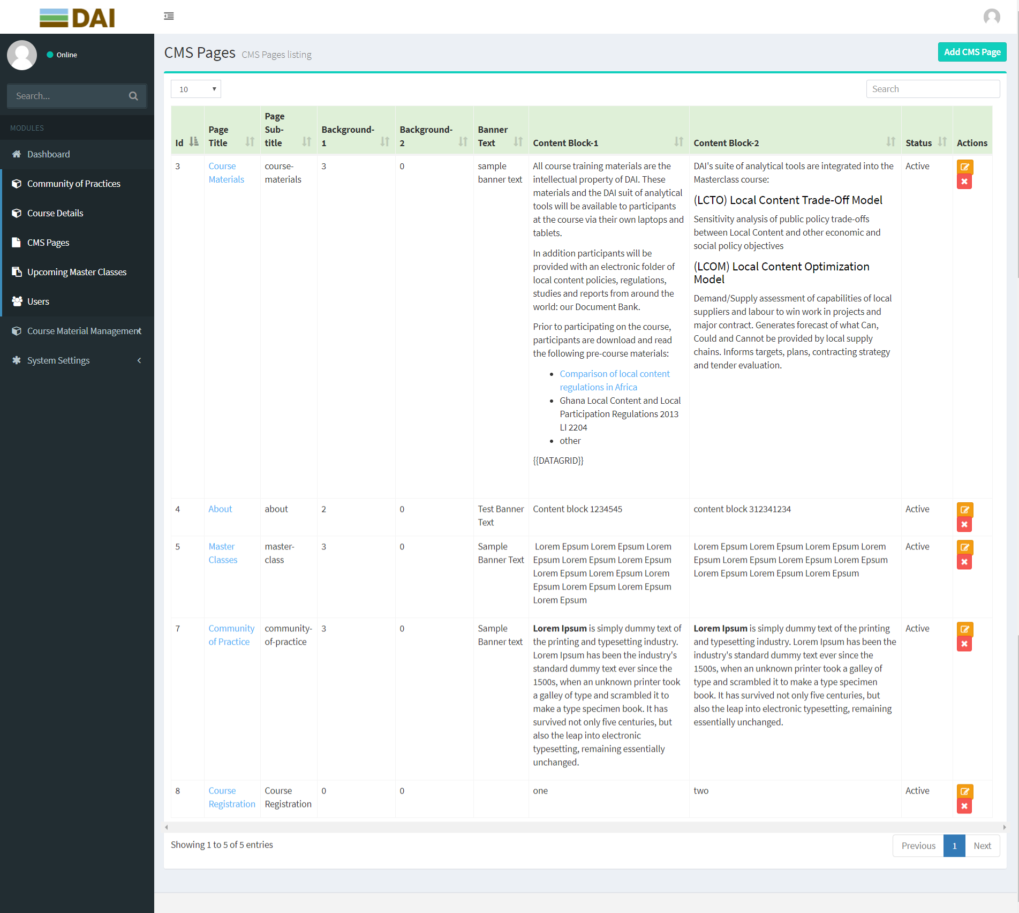

**CMS Page: About the field PAGE TITLE**

This is the CMS page. Here when we click on Course Materials then we will get all the information about course material page.

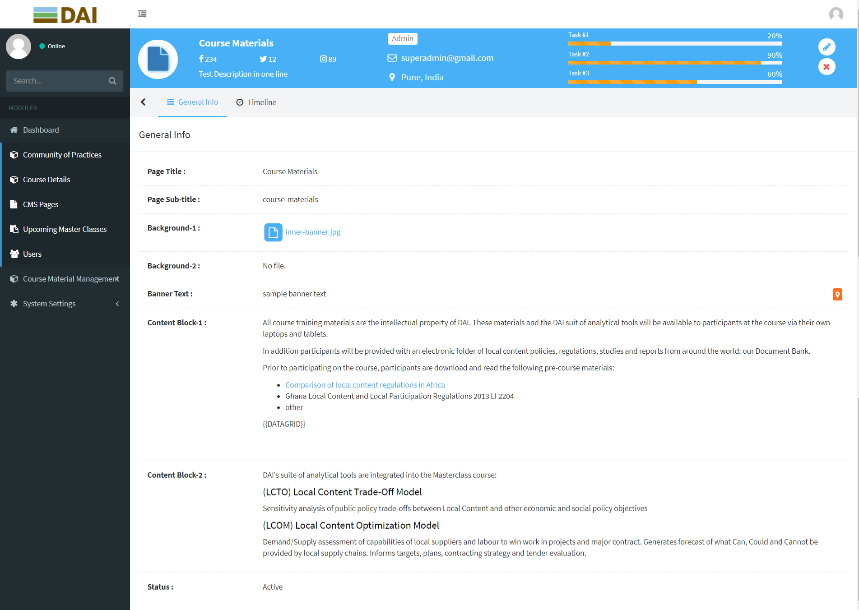

**CMS Page: ACTIONS-> EDIT ICON**

This is the CMS page. Here we have given the Add / Edit / Remove in actions field and when we click on edit option the below page will display so that we can edit the changes and we can update it.

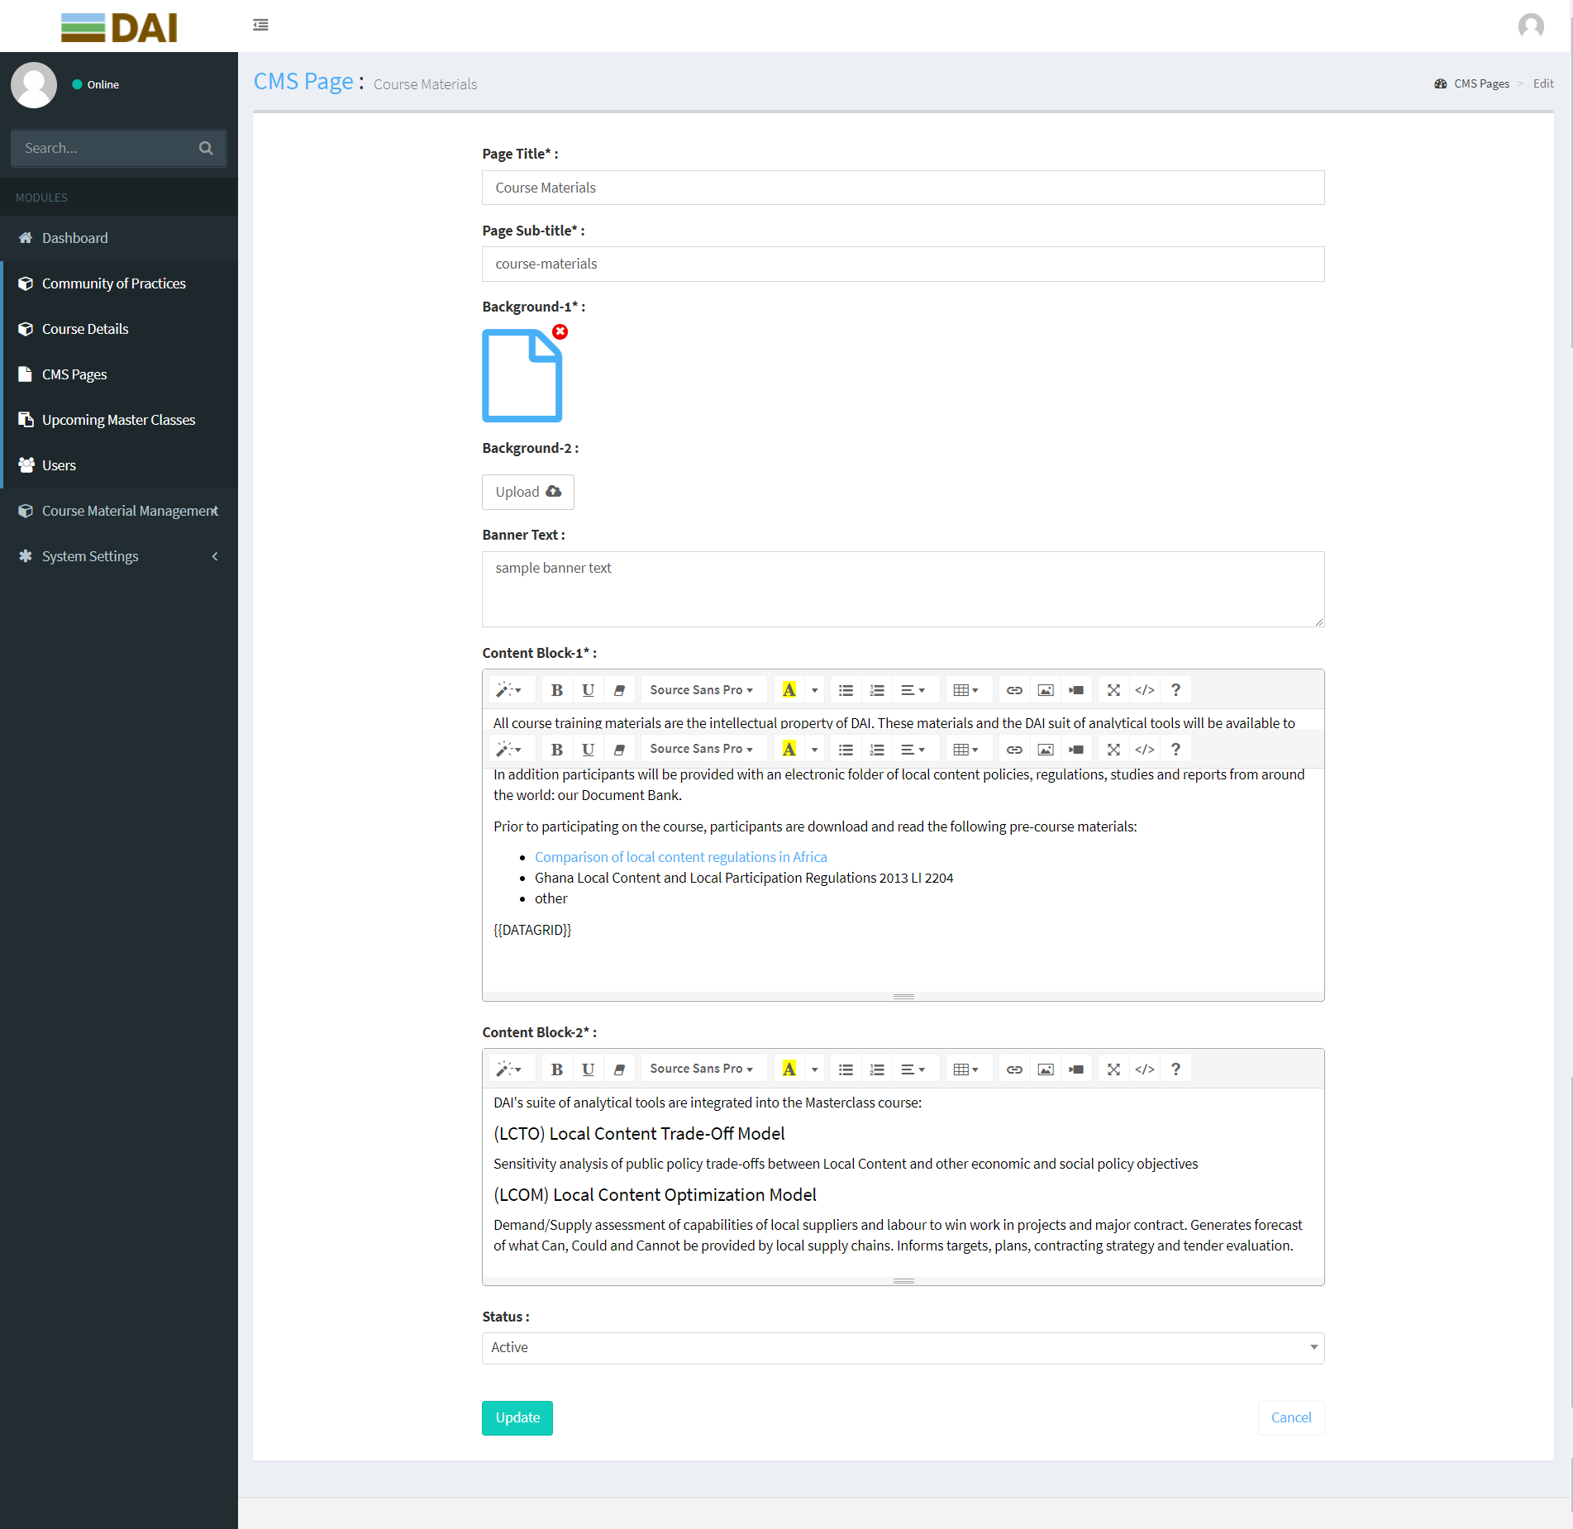

**About the Screen:**

Once we updated with all the pages and images then it will get updated with the new content and new images.

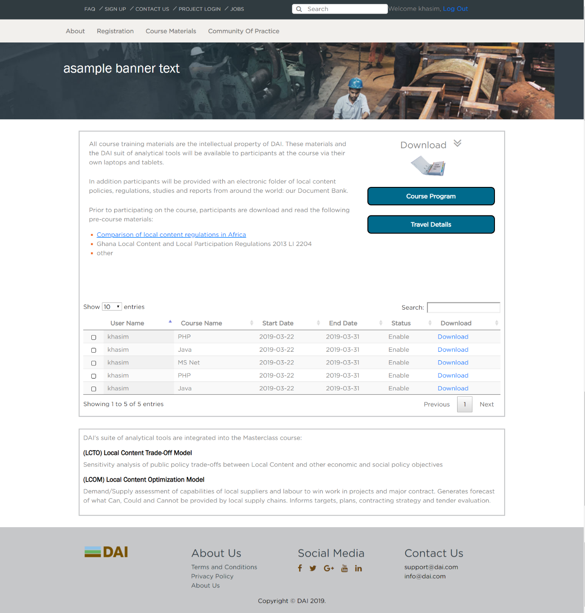

**CMS Page: ACTIONS-> REMOVE ICON**

If you want to delete a particular page in Actions column you can find a close icon. If we click on the close icon the page will be deleted and can’t be seen in the front end.



**CMS Pages: ADD CMS PAGE**

If you want to create a new CMS page on the top right-side corner, you can find a button with the name “ADD CMS PAGE”.

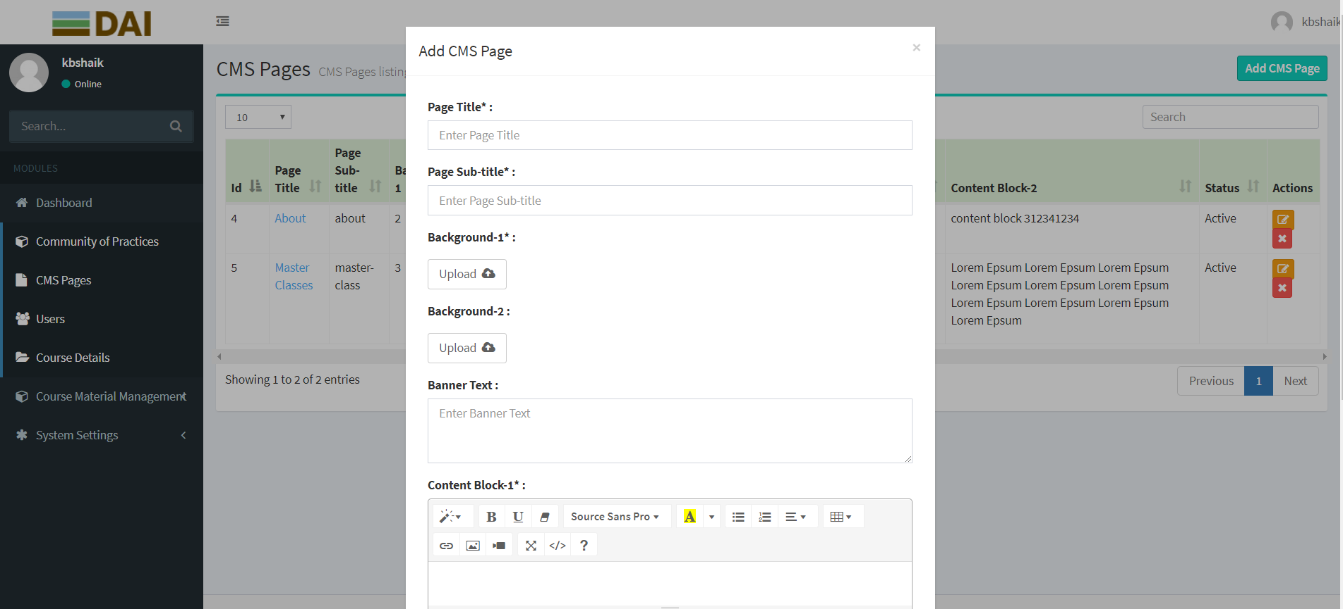

**About the Screen:**

Once we click on the add CMS page button you will find the pop-up with related fields to create the new CMS page.

# UPCOMING MASTER CLASSES:

In this page we can add upcoming master classes and display them like above image.

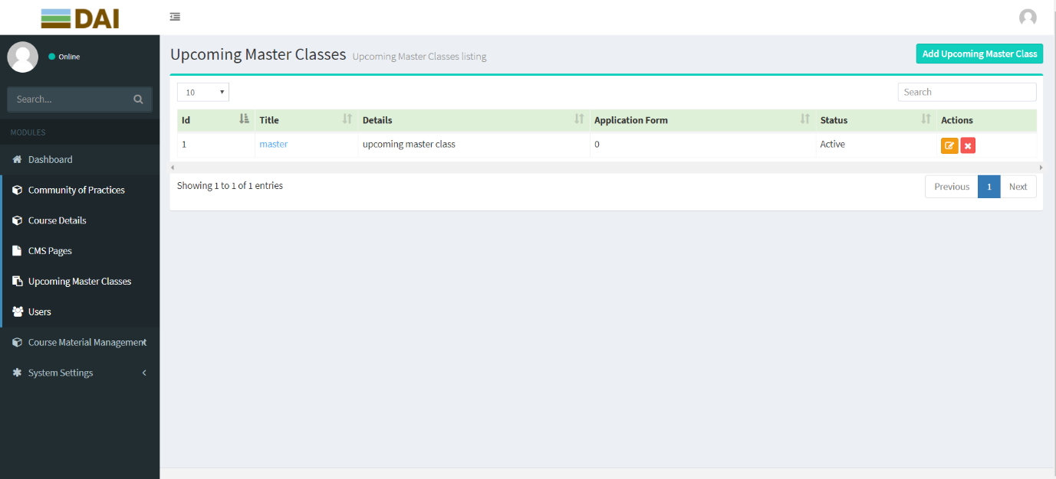

**UPCOMING MASTER CLASSES:** **About the field TITLE:**

In this page when we click on the particular upcoming master class so that we can see all the information about the upcoming master class.

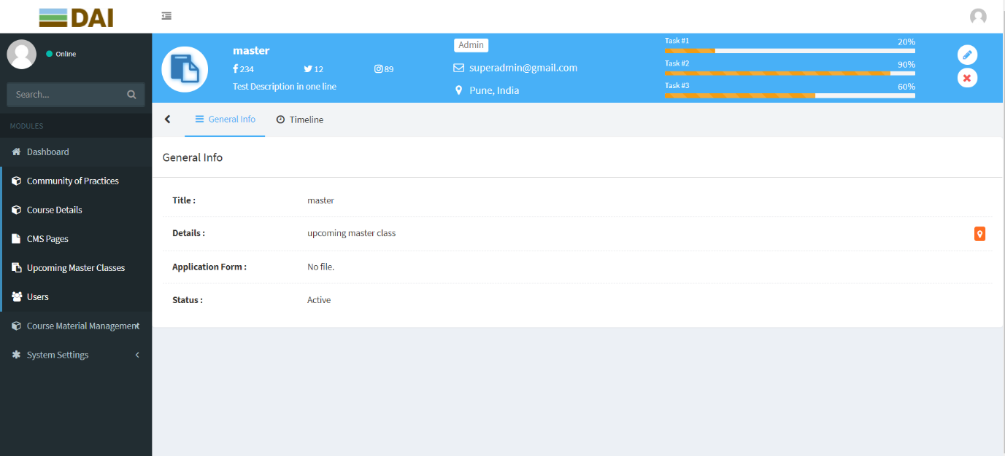

**UPCOMING MASTER CLASSES: ACTIONS-> EDIT ICON**

Here we have given the Add / Edit / Remove in actions field and when we click on edit option the below page will display so that we can edit the changes and we can update it.

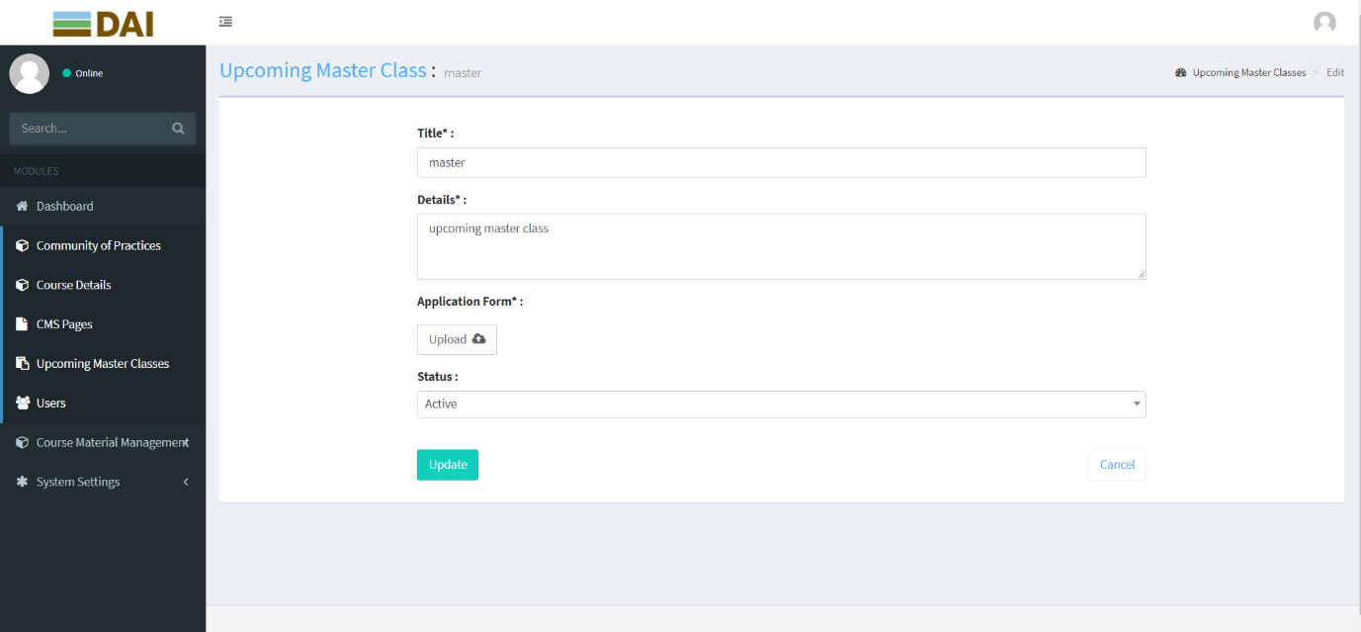

**About the Screen:**

Once we updated with all the pages and images then it will get updated with the new content and new images.

**UPCOMING MASTER CLASSES: ACTIONS-> REMOVE ICON**

If you want to delete a particular page in Actions column you can find a close icon. If we click on the close icon the page will be deleted and can’t be seen.

.

**UPCOMING MASTER CLASSES: ADD UPCOMING MASTER CLASSES**

If you want to create a new UPCOMING MASTER CLASS page on the top right-side corner, you can find a button with the name “ADD UPCOMING MASTER CLASS”.

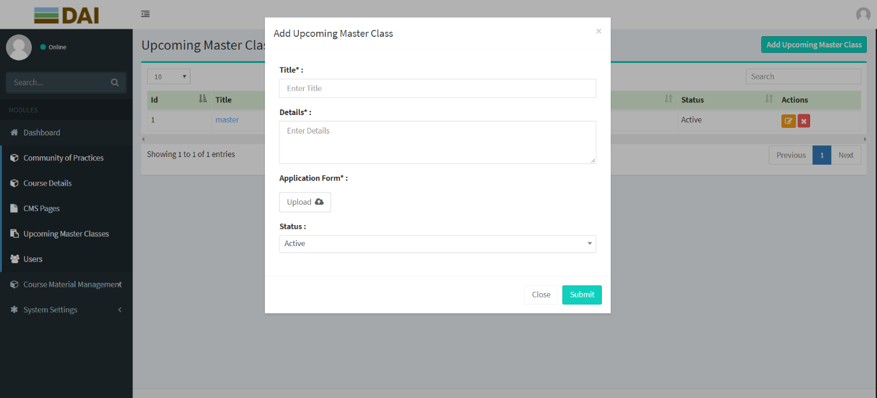

**About the Screen:**

Once we click on the add CUPCOMING MASTER CLASS page button you will find the pop-up with related fields to create the new UPCOMING MASTER CLASS page.

# USERS MODULE:

In this page we can create/Manage a username, password and Email, credentials to the user from the admin.

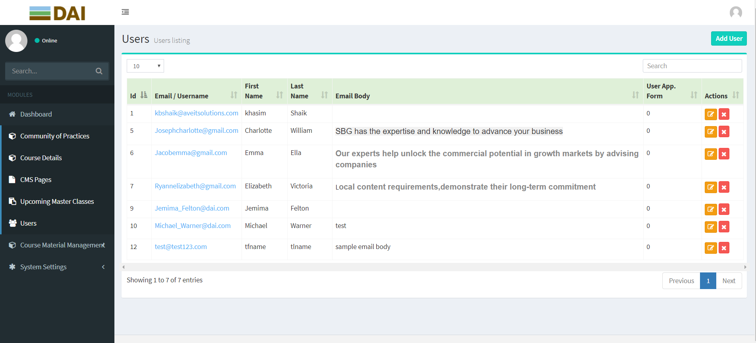

**USERS MODULE:** **About the field NAME:**

In this page when we click on the particular user, we can see all the information about the user.

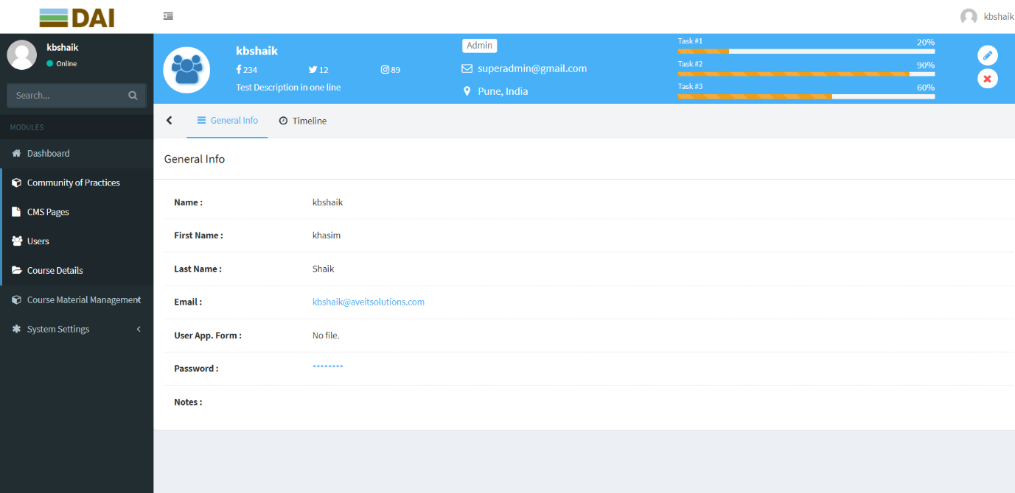

**USERS Module: ACTIONS-> EDIT ICON**

Here we have given the Add / Edit / Remove in actions field and when we click on edit option the below page will display so that we can edit the changes and we can update it.

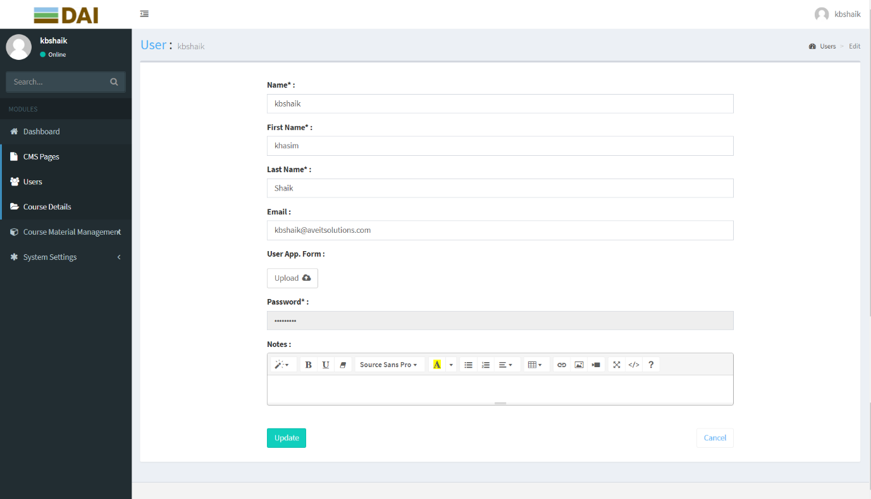

**About the Screen:**

Once we updated with all the pages and images then it will get updated with the new content and new images.

**USERS Page: ACTIONS-> REMOVE ICON**

If you want to delete a particular page in Actions column you can find a close icon. If we click on the close icon the page will be deleted and can’t be seen.

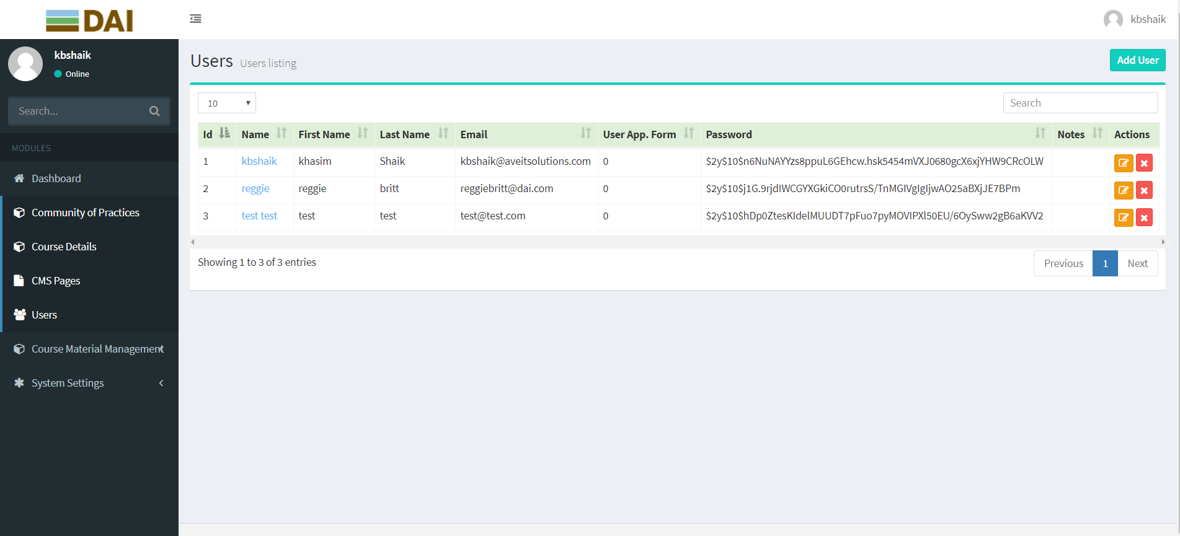

**USERS MODULE: ADD USER**

If you want to create a new USER page on the top right-side corner, you can find a button with the name “ADD USER”.

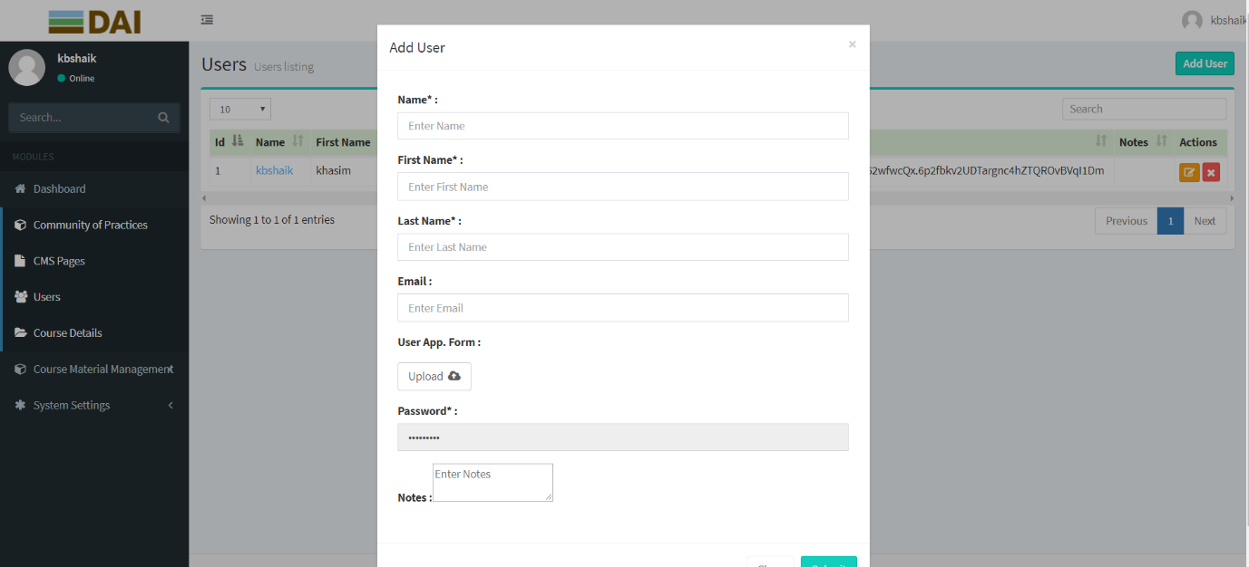

**About the Screen:**

Once we click on the add CMS page button you will find the pop-up with related fields to create the new USER page.

# COURSE MATERIAL MANAGEMENT:

In this course material management, we have two modules:

1)Manage Course Materials.

2)Assign Course Materials.

**MANAGE COURSE MANAGEMENT:**

In manage course management module we will manage the content of the page and the fields provided in this page are Id, Course Name, Course Material, Actions.

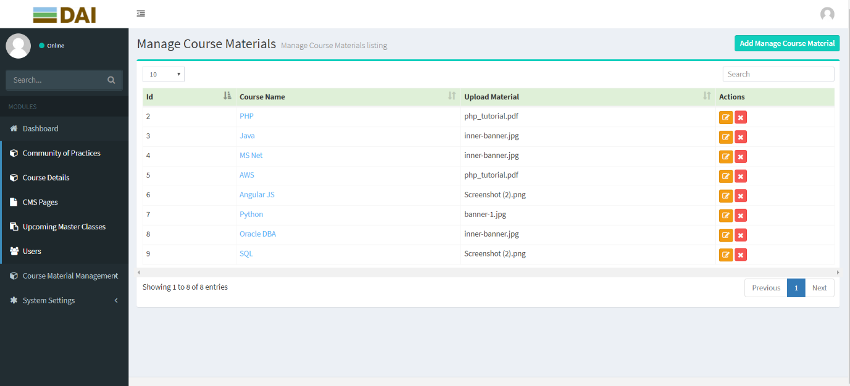

**About the field COURSE NAME:**

This is the manage course materials page. Here when we click on Course Name then we will get all the information about course name page.

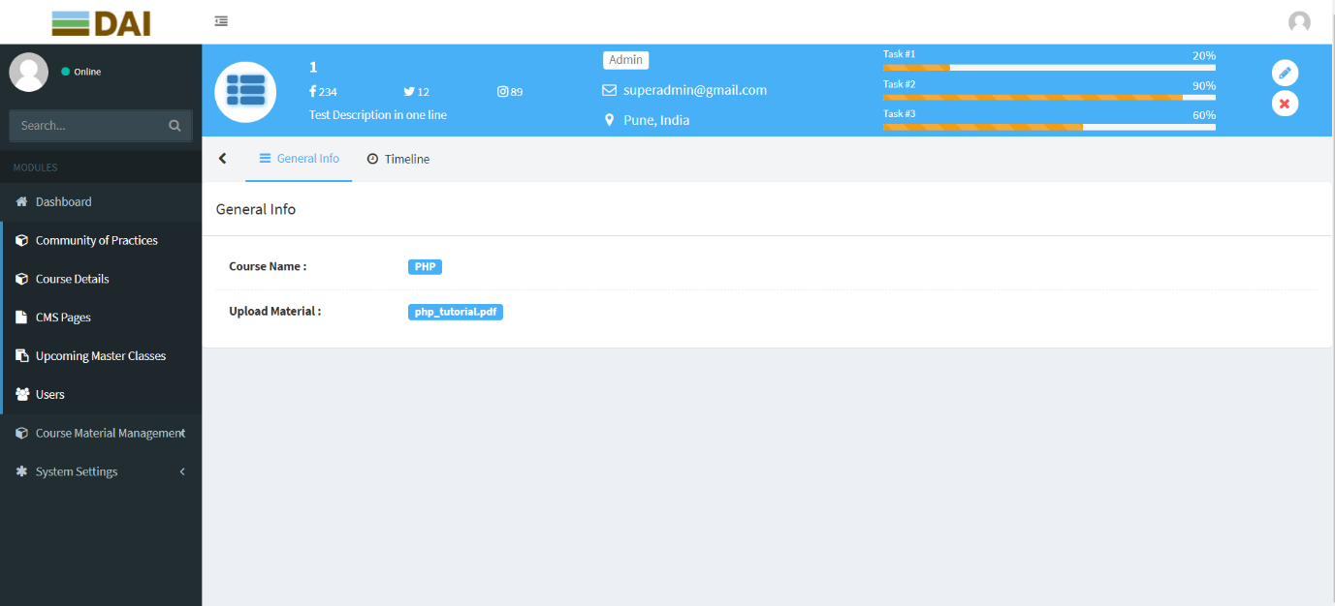

**MANAGE COURSE MANAGEMENT Page: ACTIONS-> EDIT ICON**

Here we have given the Add / Edit / Remove in actions field and when we click on edit option the below page will display so that we can edit the changes and we can update it.

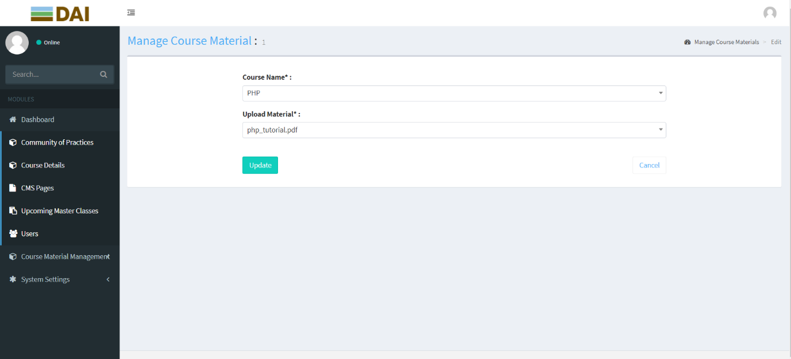

**About the Screen:**

Once we updated with all the pages and images then it will get updated with the new content and new images.

**MANAGE COURSE MANAGEMENT Page: ACTIONS-> REMOVE ICON**

If you want to delete a particular page in Actions column you can find a close icon. If we click on the close icon the particular page will be deleted and can’t be seen.



**MANAGE COURSE MANAGEMENT Page: ADD MANAGE COURSE MATERIAL Module**

If you want to create a new MANAGE COURSE MATERIAL page on the top right-side corner, you can find a button with the name “ADD MANAGE COURSE MATERIAL”.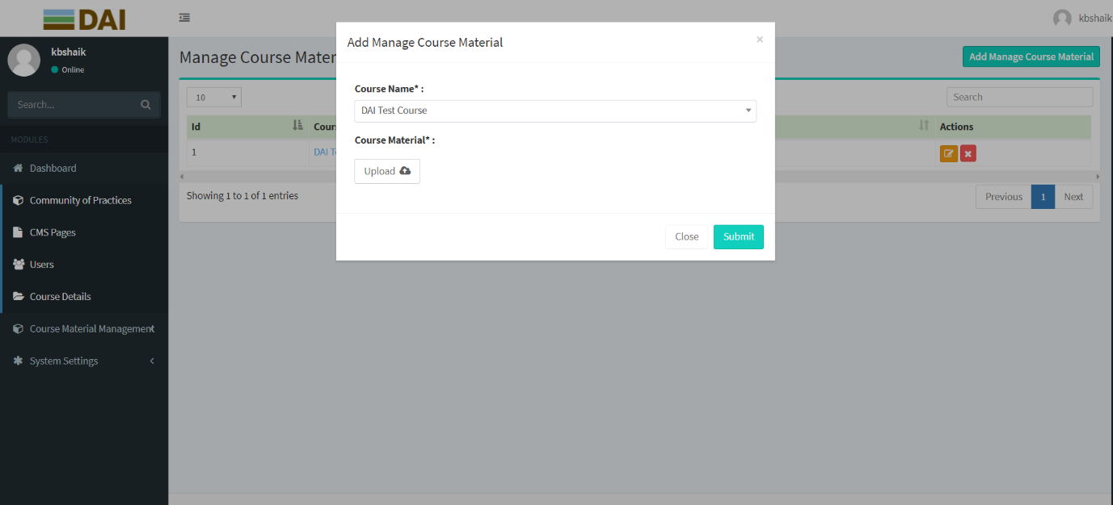

**About the Screen:**

Once we click on the add MANAGE COURSE MATERIAL page button you will find the pop-up with related fields to create the new MANAGE COURSE MATERIAL page.

**ASSIGN COURSE MATERIALS:**

In assign course material module, we will manage the content of the page and the fields provided in this page are Id, Course Name, User Name, Start Date, End Date, Status, Actions.

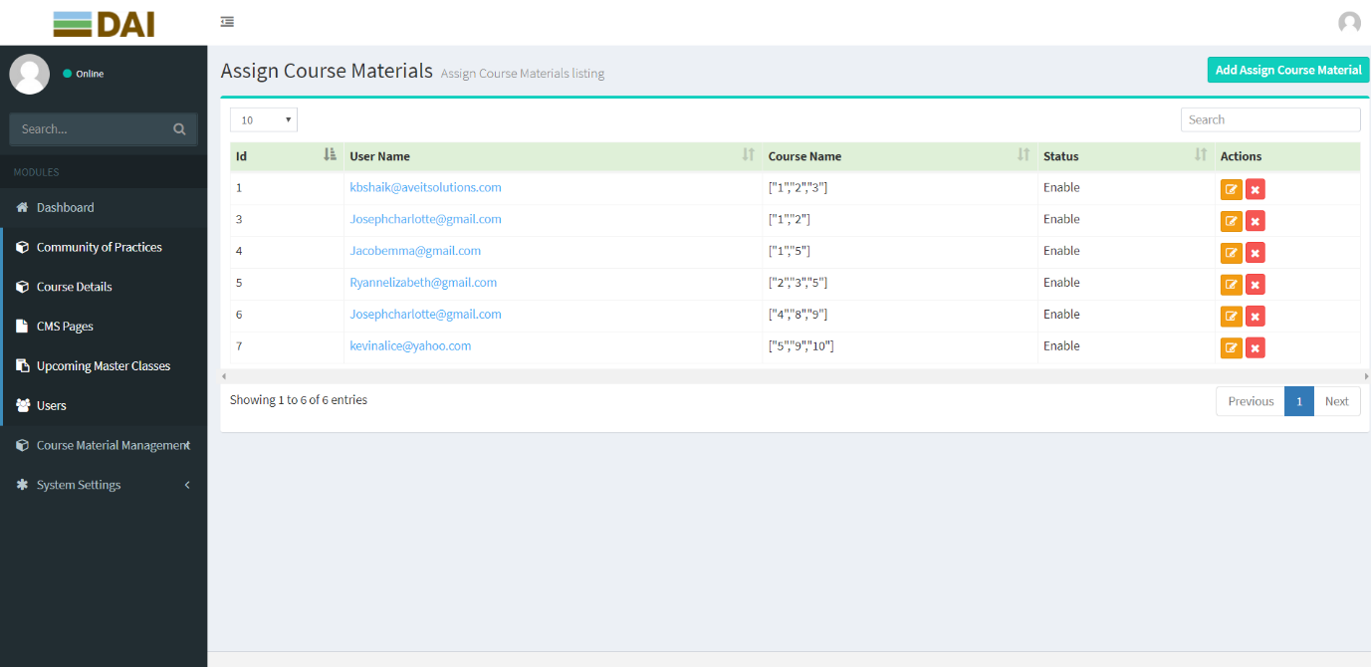

**About the field COURSE NAME:**

This is the assign course material page. Here when we click on DAI TEST COURSE, we will get all the information about dai test course page.

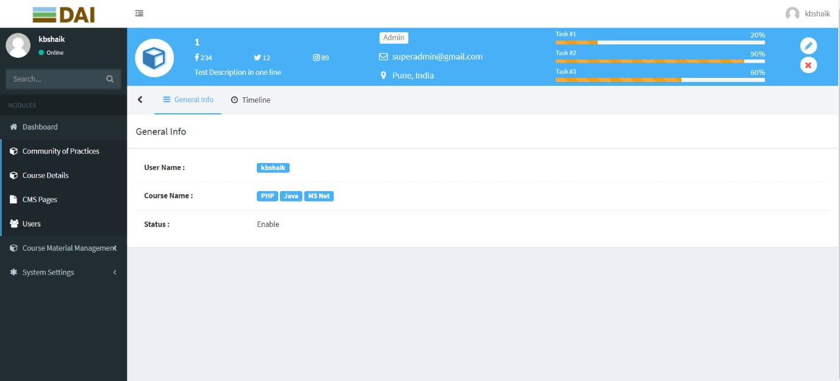

**ASSIGN COURSE MATERIALS Page: ACTIONS-> EDIT ICON**

Here we have given the Add / Edit / Remove in actions field and when we click on edit option the below page will display so that we can edit the changes and we can update it.

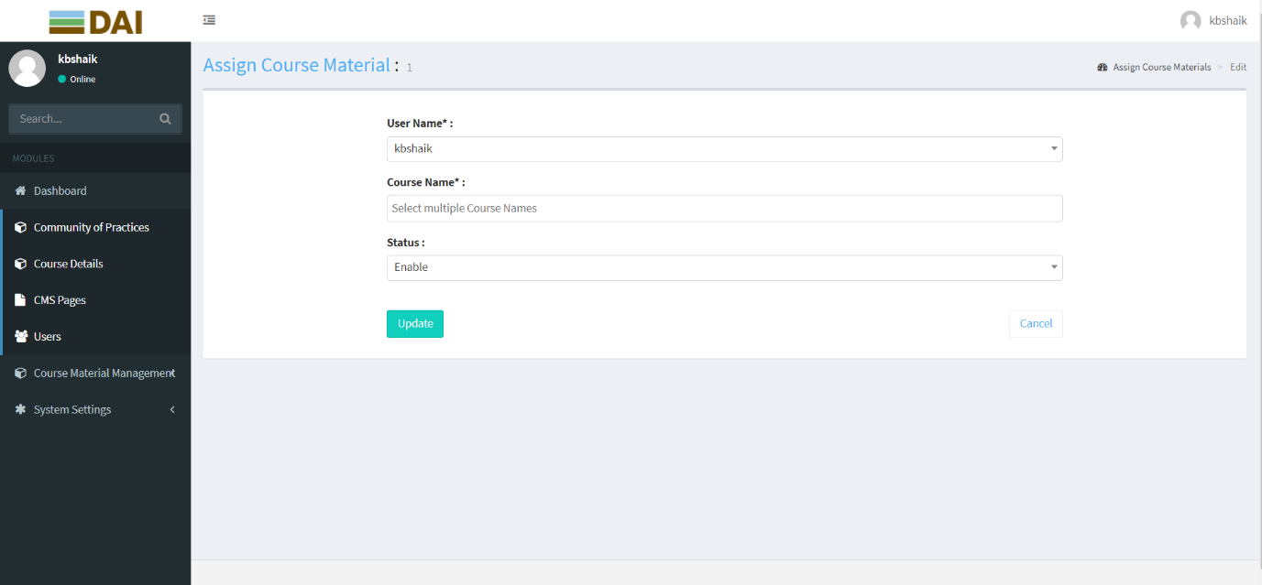

**About the Screen:**

Once we updated with all the pages and images then it will get updated with the new content and new images.

**ASSIGN COURSE MATERIALS Page: ACTIONS-> REMOVE ICON**

If you want to delete a particular page in Actions column you can find a close icon. If we click on the close icon the particular page will be deleted and can’t be seen.

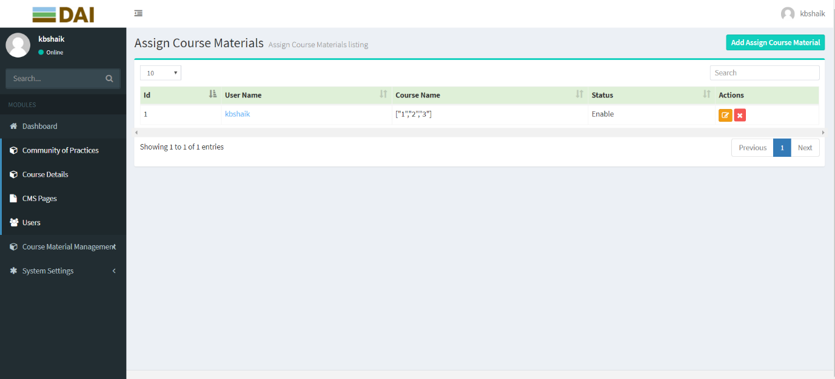

**ASSIGN COURSE MATERIALS Page: ADD ASSIGN COURSE MATERIALS Module**

If you want to create a new ASSIGN COURSE MATERIAL page on the top right-side corner, you can find a button with the name “ADD COURSE MATERIAL”.

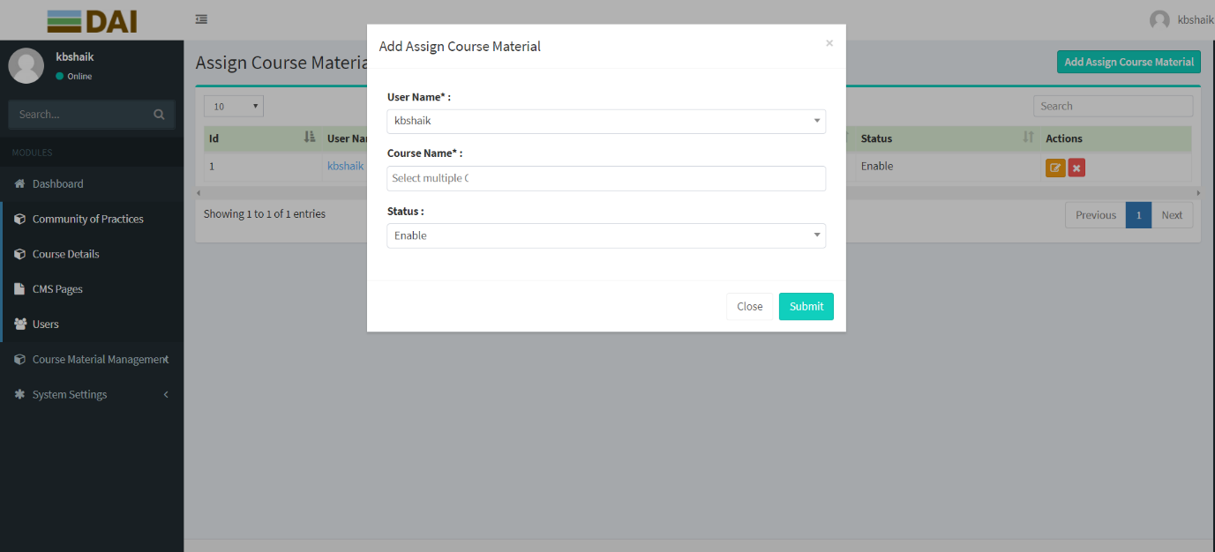

**About the Screen:**

Once we click on the add ASSIGN COURSE MATERIAL page button you will find the pop-up with related fields to create the new ASSIGN COURSE MATERIAL page.

Confidentiality Statement / Disclaimer

This document is the confidential property of Suneratech. No part of this document shall be reproduced, stored in a retrieval system, or transmitted by any means, electronic, mechanical, or otherwise, to parties outside of your organization without prior written permission from Suneratech.

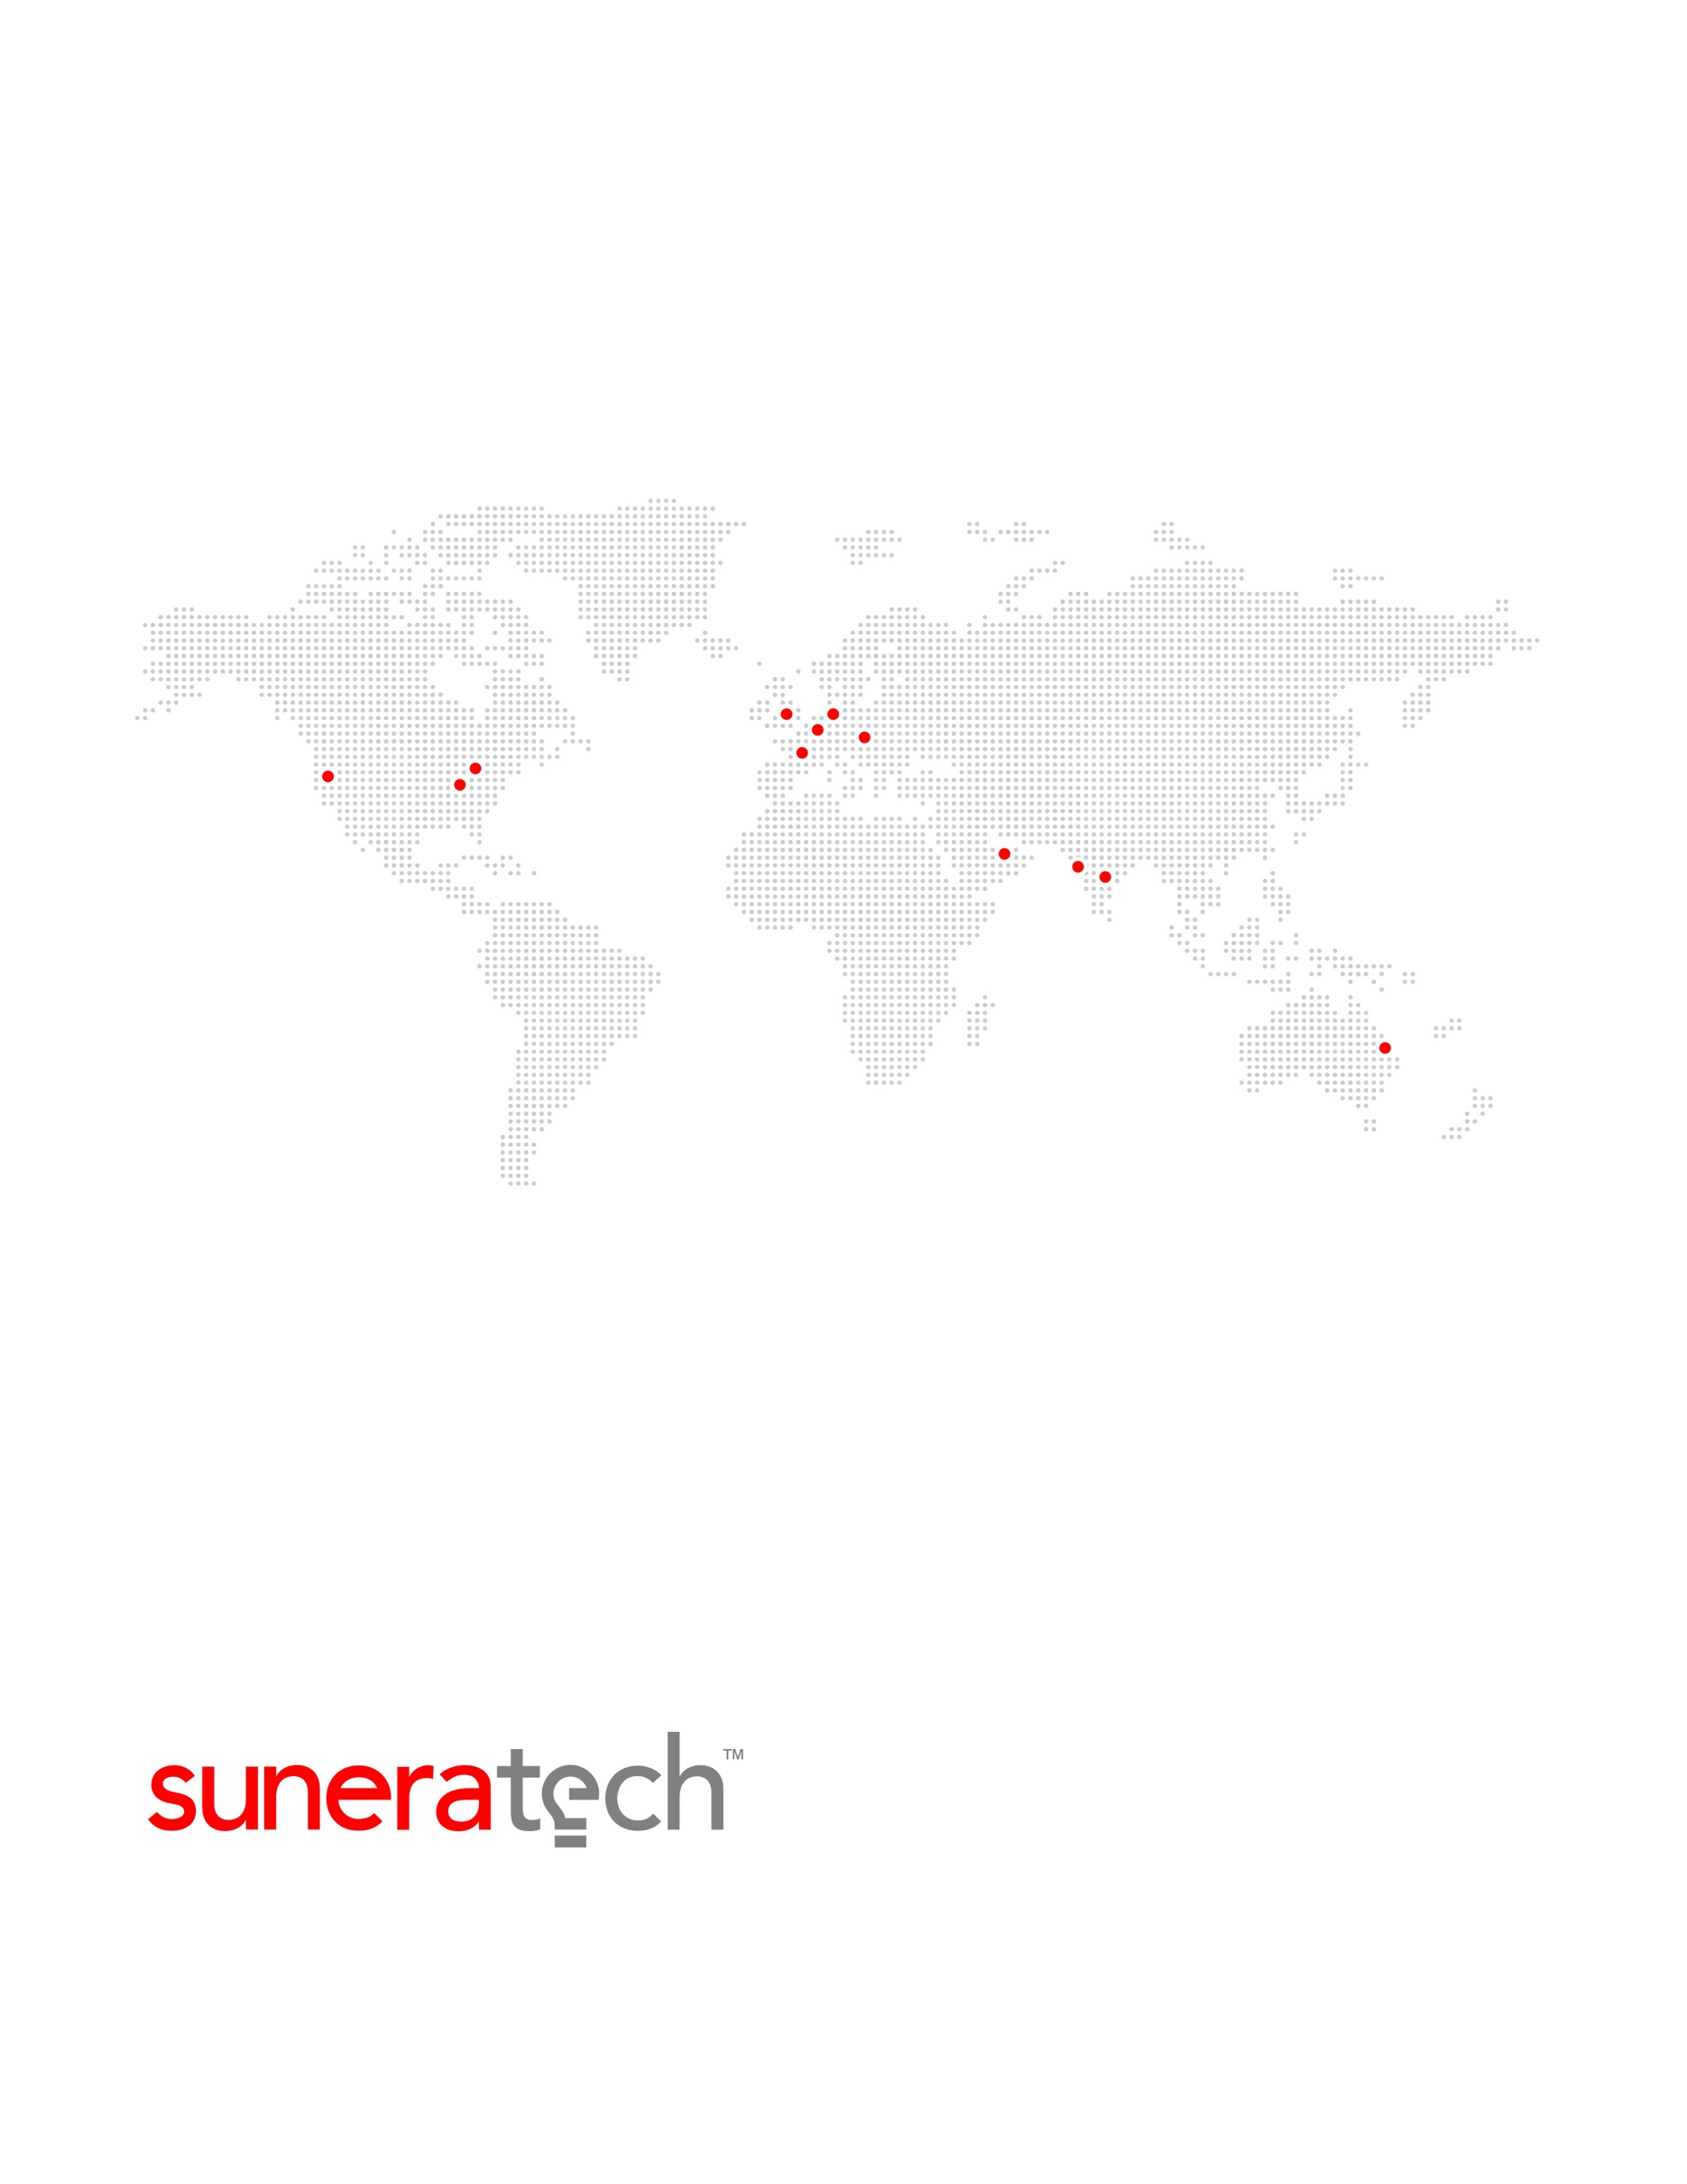

AMERICAS | ASIA | AUSTRALASIA | EUROPE

© 2017. All rights reserved. Suneratech and all other related logos are either registered trademarks of Sunera Technologies in the United States, and/or other countries.

All other company and service names are the proprietary of their respective holders and may be registered trademarks or trademarks in the United States and/or other countries.

AMERICAS | ASIA | AUSTRALASIA | EUROPE

©2017. All rights reserved. Suneratech and all other related logos are either registered trademarks of Sunera Technologies in the United States, and/or other countries.

All other company and service names are the proprietary of their respective holders and may be registered trademarks or trademarks in the United States and/or other countries.